# Title

**First name Last name**

Position, Institution

Address, email address

KEYWORDS: 5 keywords

ABSTRACT

Max 200 words

The abstract should summarize the problem and objective of your paper and discuss the method, results, conclusions, and future research directions if appropriate.

HEADINGS 1

Article should be approximately between 5,000-8,000 words, excluding tables, figures, and references.

Main body of text;

12-point Times New Roman,

Interline 1.15;

Justified

Sub-headings

Main body of Text Justified

**Tables**

11-point Times New Roman,

**Table number – Title**

|  |  |  |
| --- | --- | --- |
|  |  |  |
|  |  |  |
|  |  |  |

Source: Last name (year); or if original table: Source: Author(s).

**Figures**

Resolution: 300 dpi B/W or Colour.

Dimension: 6.25” x 4.2”

**Figure 1 - A trend comparison between total tenure track positions and PhD titles awarded in ICAR**

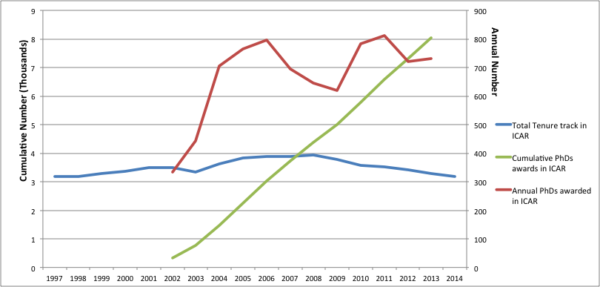

Source: Authors’ Elaboration on data from MIUR database (2015a).

**Footnotes**

Please, try to limit the use of footnotes.

REFERENCES

IJPP uses the American Psychological Association style for references.

Examples for Journal papers:

Mazza, L. (2002). Technical Knowledge and Planning Actions. Planning Theory, 1(1), 11-26. Doi: 10.1177/147309520200100102.

Goldstein, H.A., & Carmin, J.A. (2006). Compact, Diffuse, or Would-be Discipline?: Assessing Cohesion in Planning Scholarship, 1963-2002. Journal of Planning Education and Research, 26(1), 66-79. Doi: 10.1177/0739456X05282353.

Examples for Books:

Boyer, E.L. (1990). Scholarship reconsidered. Priorities of the Professoriate. Menlo Park, CA: The Carnegie Foundation for the Advancement of Teaching.

For other types of references refer to the style available at: <https://owl.english.purdue.edu/owl/resource/560/06/>

SHORT AUTHOR BIOGRAPHY:

Max two sentences.

The Author is associate professor at XYZ University, Department XYZ. His/Her research interests include public participation in planning, property rights, tourism, landscape analysis, etc. etc. She/he has published in: title of journals if appropriate.